*Kate Interviewed Courtney Aitken on October 14, 2020*

**Interview Questions--Kate:**

1. How often do you workout weekly?
2. Has COVID impacted how you workout?
   1. Can you tell me about a specific instance of how it impacted your workout?
   2. Can you describe an instance (non-medical) during the COVID pandemic that made you stop working out.
   3. Can you describe an instance during the pandemic of you working out.
3. Do you like to buddy up when working out?
   1. If you do, how do you buddy up: in person or virtually?
4. Would adding another person to your workout schedule hold you more accountable?
   1. If yes- What drives you to feel that the other person holds you accountable?
5. What is your purpose for working out?
6. What type of workouts do you do?
   1. Expected Responses: ( HIIT, cardio, weight training)
   2. If multiple- What combination of workouts fit into your week?
7. How do you normally plan your regimen?
8. What kind of equipment do you use to workout?
   1. What type of equipment do you find yourself using most often
9. Where do you workout now?
   1. Where did you workout before COVID?
10. Did you ever take part in workout classes?
    1. If yes- Can you describe a specific instance where you felt motivated to workout during the class?
11. What time of day do you enjoy working out at?
    1. What makes that time of day more desirable than the rest?

**Interview Notes--Kate:**

Courtney works out around 3-4 times a week.*(1)* Covid has impacted the way Courtney works out because now she has to figure out how to workout in her own home. She says sometimes it’s difficult when school becomes intense for her to have the motivation to workout in the house due to covid. She also doesn’t want to work out with a mask on.*(2)* She does not like buddying up in person, but has done virtual workout classes.*(3)* She states that adding another person to her workout *might* hold her more accountable, but she doesn’t know. She says that getting the notification that someone else is working out would definitely hold her more accountable.*(4)* Courtney states that her purpose for working out is to better her health mentally and physically.*(5)* She normally does circuits consisting of HIIT circuits ranging from legs, core, whole body, etc. She also bikes indoors.*(6)* She plans her regimens through a book that she goes off of which has 12 weeks laid out for her.*(7)* Courtney uses a yoga mat, medicine balls, kettlebells, hand weights, a step, and a bike stand.*(8)* Courtney works out in her room now, and before she did a combo of at home and at the gym.*(9)* She takes part in classes normally when she is at home and states that she does enjoy it because it’s more mindless and less effort. When it is a class it is enjoyable because it feels easier, but going to the gym isn’t ideal.*(10)* Courtney generally works out whenever she has finished her schoolwork. This makes it easier for her to get all of the important assignments out of the way and focus on herself.*(11)*

*John Interviewed Joe Courington on October 14, 2020*

**Interview Questions--John:**

1. How often do you workout weekly?
2. Has COVID impacted how you workout?
   1. Can you tell me about a specific instance of how it impacted your workout?
   2. Can you describe an instance (non-medical) during the COVID pandemic that made you stop working out.
   3. Can you describe an instance during the pandemic of you working out.
3. Do you like to buddy up when working out?
   1. If you do, how do you buddy up: in person or virtually?
4. Would adding another person to your workout schedule hold you more accountable?
   1. If yes- What drives you to feel that the other person holds you accountable?
5. What is your purpose for working out?
6. What type of workouts do you do?
   1. Expected Responses: ( HIIT, cardio, weight training)
   2. If multiple- What combination of workouts fit into your week?
7. How do you normally plan your regimen?
8. What kind of equipment do you use to workout?
   1. What type of equipment do you find yourself using most often
9. Where do you workout now?
   1. Where did you workout before COVID?
10. Did you ever take part in workout classes?
    1. If yes- Can you describe a specific instance where you felt motivated to workout during the class?
11. What time of day do you enjoy working out at?
    1. What makes that time of day more desirable than the rest?

Link to full document: <https://docs.google.com/document/d/1Szxjot3K7towjSjNr4x9B5IaoIXG4xjxG2dD2RKxGmU/edit?usp=sharing>

**Interview Notes--John:**

Joe works out around 3 out of 7 days of the week.*(1)* COVID has definitely affected how he worksout.*(2)* He usually would go to the CU Boulder rec center; however, the new system at the gym of registering for hour time slots did not seem to be the best option for him. It is not possible for him to go to the Rec Center with “convenience”.*(2a)* Over summer it was hard for Joe to find motivation to be fit because he had only access to body weight exercises and did not have access to weight for strength training. He feels less motivated because body weight exercises feel as if he does not make progress doing them, and is a strenuous toll on the body so it was hard to repeat weekly. *(2b)* A usual workout during the summer for Joe would consist of running for aerobic exercise, paired with multiple sets of push ups and situps. *(2c)* Joe definitely likes to buddy up when working out and does those workouts with a mask but in person. *(3,3a)*

He does feel that working out with a partner with a strict structured schedule will allow him to adhere to the same schedule.*(4,4a)* Joe’s purpose for working out is mostly for his own mental health and overall benefits of feeling more energized and better through the day.*(5)* He mostly focuses on strength training with the occasional run. (6) Joe says most times he does what his partner does, and does not have a strict schedule. (7) He uses free weights,cables, and machines; in fact, most frequently finds himself using free weights. *(8,8a)* Joe worksout at crunch and before COVID worked out at the Rec Center. *(9,9a)* Joe has never taken part in any workout class, and does not want to try one. *(10)* He favors lifting weights in the morning and running in the afternoon. Joe prefers lifting weights in the morning because he enjoys not being completely warm in the morning. He feels that his muscles perform better by starting them slightly cold. *(11,11a)*

**Affinity Diagram:**

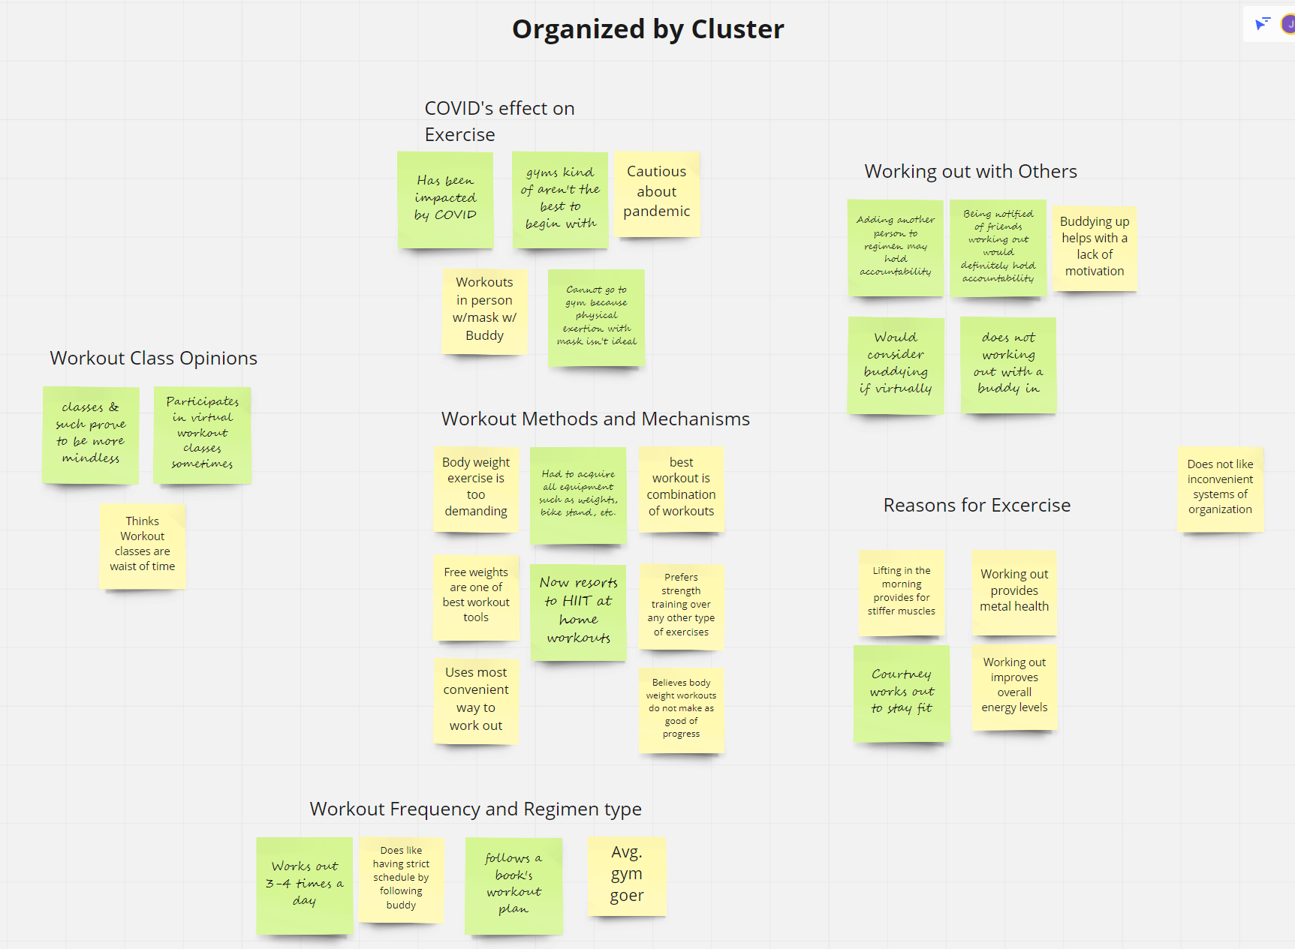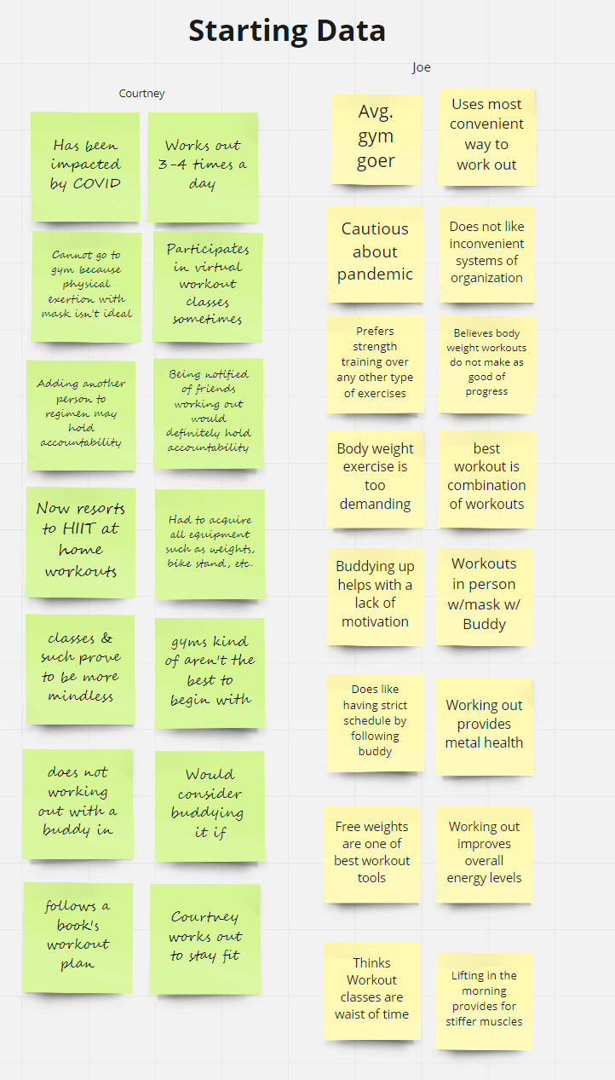

**Link:** [**https://miro.com/app/board/o9J_kiO5eIw=/**](https://miro.com/app/board/o9J_kiO5eIw=/)